document management system)

18021 Cowan, Irvine, CA 92614

[www.MBITwireless.com](http://www.mbitwireless.com)

Phone: 949-205-4559, Fax: 949-756-0629

Table of Contents

[1. About this document 7](#_Toc88132705)

[1.1. Purpose 7](#_Toc88132706)

[1.2. Audience 7](#_Toc88132707)

[1.3. Abbreviations 7](#_Toc88132708)

[1.4. Feedback 7](#_Toc88132709)

[2. Introduction 8](#_Toc88132710)

[2.1. Importance of file management 8](#_Toc88132711)

[2.1.1. Important aspects of document control 8](#_Toc88132712)

[2.1.2. Benefits of document management system 8](#_Toc88132713)

[3. Tool launch 9](#_Toc88132714)

[4. Home page 10](#_Toc88132715)

[4.1. File 11](#_Toc88132716)

[4.2. Personal 11](#_Toc88132717)

[4.2.1. Profile 11](#_Toc88132718)

[4.2.2. Change password 12](#_Toc88132719)

[4.2.3. Contacts 13](#_Toc88132720)

[4.2.4. Remove cookies 14](#_Toc88132721)

[4.3. Tools 14](#_Toc88132722)

[4.3.1. Dropbox 14](#_Toc88132723)

[4.3.2. Text content 14](#_Toc88132724)

[4.4. Screen view 16](#_Toc88132725)

[4.5. Dashboard 16](#_Toc88132726)

[4.5.1. User 16](#_Toc88132727)

[4.5.2. Tags 18](#_Toc88132728)

[4.5.3. Messages 18](#_Toc88132729)

[4.6. Document and folder operations 20](#_Toc88132730)

[4.6.1. Browser 21](#_Toc88132731)

[4.6.2. Bookmarks 24](#_Toc88132732)

[4.6.3. Trash 26](#_Toc88132733)

[4.7. Search documents 26](#_Toc88132734)

[4.7.1. Full-text search 27](#_Toc88132735)

[4.7.2. Search by tags 28](#_Toc88132736)

[4.7.3. Search by folder 29](#_Toc88132737)

[4.8. Status bar icons 31](#_Toc88132738)

[5. Folder management 32](#_Toc88132739)

[5.1. Move a folder 34](#_Toc88132740)

[5.2. Copy a folder 34](#_Toc88132741)

[6. Document management 36](#_Toc88132742)

[6.1. Add documents 36](#_Toc88132743)

[6.2. Document operations 39](#_Toc88132744)

[6.2.1. Send by email 41](#_Toc88132745)

[6.2.2. Checkout 42](#_Toc88132746)

[6.2.3. Checkin 42](#_Toc88132747)

[6.2.4. Lock and unlock 44](#_Toc88132748)

List of Figures

[Figure 1. MDMS login 9](#_Toc88132749)

[Figure 2. Home page 10](#_Toc88132750)

[Figure 3. File menu 11](#_Toc88132751)

[Figure 4. Exit icon 11](#_Toc88132752)

[Figure 1. Figure 5. Request confirmation 11](#_Toc88132753)

[Figure 6. Personal menu 11](#_Toc88132754)

[Figure 7. Profile details 12](#_Toc88132755)

[Figure 8. Change password 12](#_Toc88132756)

[Figure 2. Figure 9. Contacts 13](#_Toc88132757)

[Figure 10. Contact details 13](#_Toc88132758)

[Figure 11. List of contacts 14](#_Toc88132759)

[Figure 12. Remove cookies 14](#_Toc88132760)

[Figure 3. Figure 13. Tools menu 15](#_Toc88132761)

[Figure 4. Figure 14. Create text content 15](#_Toc88132762)

[Figure 5. Figure 15. Select template 15](#_Toc88132763)

[Figure 16. File name extension 15](#_Toc88132764)

[Figure 17. Text window 16](#_Toc88132765)

[Figure 18. Types of screen view 16](#_Toc88132766)

[Figure 6. Figure 19. List of dashlets 17](#_Toc88132767)

[Figure 20. User logs 17](#_Toc88132768)

[Figure 21. Dashlet selector 17](#_Toc88132769)

[Figure 7. Figure 22. Messages 18](#_Toc88132770)

[Figure 23. Send message 19](#_Toc88132771)

[Figure 8. Figure 24. Messages 20](#_Toc88132772)

[Figure 9. Figure 25. Options in documents 21](#_Toc88132773)

[Figure 26. Folder properties 22](#_Toc88132774)

[Figure 27. Document screen 22](#_Toc88132775)

[Figure 28. External properties 23](#_Toc88132776)

[Figure 10. Figure 29. Version comment 23](#_Toc88132777)

[Figure 11. Figure 30. Add bookmark 25](#_Toc88132778)

[Figure 31. Bookmark icon 25](#_Toc88132779)

[Figure 32. List of bookmarks 26](#_Toc88132780)

[Figure 33. Delete file 26](#_Toc88132781)

[Figure 12. Figure 34. Quick search text box 27](#_Toc88132782)

[Figure 35. Search by Full-text 27](#_Toc88132783)

[Figure 13. Figure 36. Date range 28](#_Toc88132784)

[Figure 14. Figure 37. Select template 28](#_Toc88132785)

[Figure 38. Search in fields 28](#_Toc88132786)

[Figure 39. Search by folder 29](#_Toc88132787)

[Figure 15. Figure 40. Condition 29](#_Toc88132788)

[Figure 16. Figure 41. Values 30](#_Toc88132789)

[Figure 17. Figure 42. Key word 30](#_Toc88132790)

[Figure 43. Last events 31](#_Toc88132791)

[Figure 44. Documents in the folder 32](#_Toc88132792)

[Figure 45. Add new folder 32](#_Toc88132793)

[Figure 18. Figure 46. Folder operations 33](#_Toc88132794)

[Figure 19. Figure 47. Move folder 34](#_Toc88132795)

[Figure 48. Move request confirmation 34](#_Toc88132796)

[Figure 49. Copy folder 35](#_Toc88132797)

[Figure 50. Copy request confirmation 35](#_Toc88132798)

[Figure 51. Add documents 36](#_Toc88132799)

[Figure 52. File upload 37](#_Toc88132800)

[Figure 53. Set properties 37](#_Toc88132801)

[Figure 54. Set external properties 38](#_Toc88132802)

[Figure 55. Template attributes 38](#_Toc88132803)

[Figure 56. Notify users 39](#_Toc88132804)

[Figure 57. Document operations 40](#_Toc88132805)

[Figure 58. Send document by email 41](#_Toc88132806)

[Figure 59. Folder link 42](#_Toc88132807)

[Figure 60. Message notification 42](#_Toc88132808)

[Figure 61. Save document 42](#_Toc88132809)

[Figure 62. Document checkin 43](#_Toc88132810)

[Figure 63. Warning message 43](#_Toc88132811)

[Figure 64. Add external properties 44](#_Toc88132812)

[Figure 65. Version history 44](#_Toc88132813)

[Figure 66. Reason for document lock 44](#_Toc88132814)

[Figure 67. Locked document 45](#_Toc88132815)

**List of Tables**

[Table 1. Icons in the folder 23](#_Toc88132816)

[Table 2. Status bar icons 31](#_Toc88132817)

1. About this document
   1. Purpose

This document describes how to access, manage and share documents using MDMS.

* 1. Audience

This document is intended to be used across all the internal team members who create and work on documents to meet the organizational goals.

* 1. Abbreviations

|  |  |
| --- | --- |
| DMS | Document Management System |

* 1. Feedback

If you have any feedback, contact IT-Support.

1. Introduction

MDMS is a proprietary document management system that is designed to handle and share documents within an organization. MDMS is a content repository which allows a user to access, manage, track and edit stored information and organize the files.

* 1. Importance of file management

The purpose of file management is used to control, manage and maintain the documents used by the organization. Users can search and retrieve documents based on different criteria which helps to save time and work more effectively.

* + 1. Important aspects of document control
* Reviewing and approving documents before publishing.
* Ensuring the changes and revisions are clearly identified.
* Ensuring that relevant versions of applicable documents are available at their points of use.
* Ensuring that documents remain legible and identifiable.
* Ensuring that external documents (such as customer supplied documents or supplier manuals) are identified and controlled.
* Preventing unintended use of outdated documents.
  + 1. Benefits of document management system
* Reduced storage space
* Enhanced security
* Improved regulatory compliance
* Easier retrieval
* Better collaboration
* Better backup and recovery

1. Tool launch

To login to the MDMS, do the following:

1. Type the URL [**http://10.20.32.155:8080/login.jsp**](http://10.20.32.155:8080/login.jsp) in browser and then press **Enter**. A login dialog appears as shown in *Figure 1.*

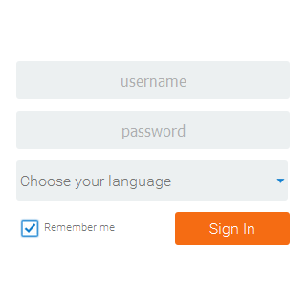

Figure 1. MDMS login

1. Type the login credentials (username and password) in the respective text boxes. The login credentials for the individual are provided by the IT team.
2. Select a language from **Choose your language** drop-down list box to drive the menus in the system.
3. If language is not specified, the last selected language by the previous user will be used automatically.
4. Select the **Remember me** check box to save the login credentials on local machine for quick access in the future.
5. Click **Sign In**.
6. Home page

A home page appears when user sign in to MDMS as shown in *Figure 2*. The home page consists **Title bar**, **Main menu**, **Work area panel** and **Status bar**.

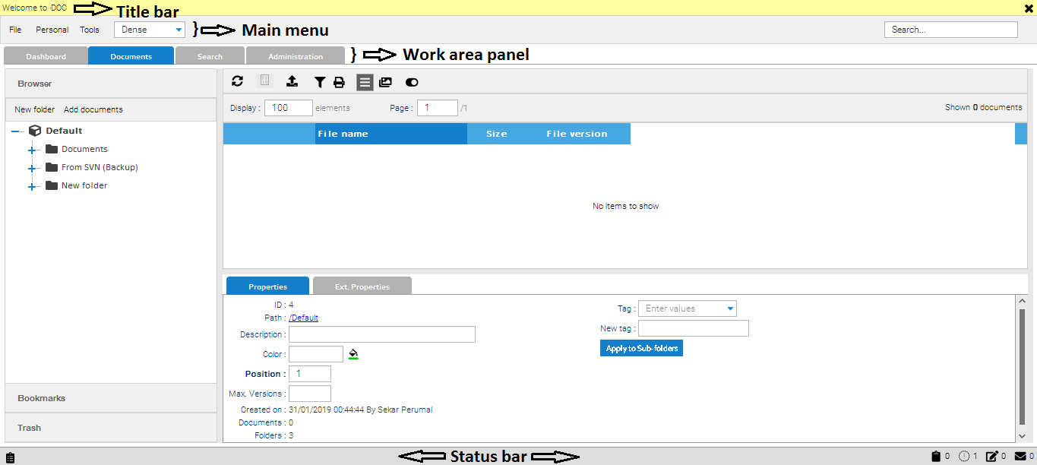

Figure 2. Home page

* **Title bar** displays the welcome message as **Welcome to DOC**.
* **Main menu** contains the following:
* **File**, **Personal**, **Tools** tabs
* screen view drop-down list box
* exit icon 
* quick **Search** box
* **Work area panel** contains **Dashboard**, **Documents**, **Search** and **Administration** tabs.
* **Status bar** contains last events \\INCHWSHR1\Technical_Documentation\MDMS\Last events icon.PNG, clipboard , documents locked , checked out  and messages  icons.
  1. File

The file menu helps in closing the current session.

To close the current session, do the following:

1. Click the **File** menu and then click **Exit** as shown in *Figure 3***Error! Reference source not found.** or click  on the upper-right corner of the main menu area as shown in *Figure 4*. The **Question** dialog appears for confirmation.

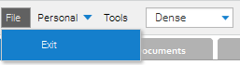

Figure 3. File menu



Figure 4. Exit icon

1. Click **Yes** to confirm or click **No** to cancel the request as shown in *Figure 5*.

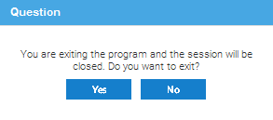

1. Figure 5. Request confirmation
   1. Personal

When the account is created, a profile also created. User can change the profile details after sign in to MDMS. The **Personal** menu contains **Profile**, **Change password**, **Contacts** and **Remove cookies**.

* + 1. Profile

To change the profile details, do the following:

1. Click **Personal** in the main menu area and then click **Profile** as shown in *Figure 6*. The **Profile** dialog appears as shown in *Figure 7*.

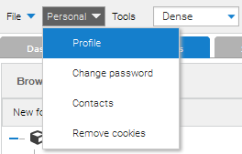

Figure 6. Personal menu

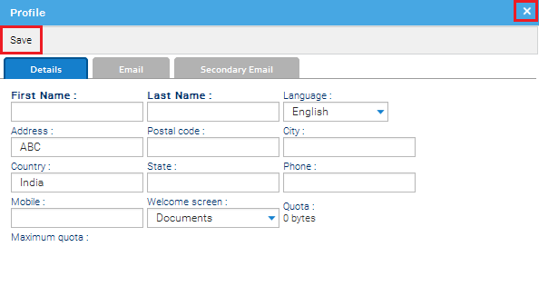

Figure 7. Profile details

* **Details:** **First Name**, **Last Name**, **Language** are added when user ID is created. If user wants to add any additional information, details can be added and saved.
* **Email:** Email ID (Outlook mail ID) is saved automatically when user ID is created. If needed, user can add any official or personal email ID in the **Secondary Email** ID.

1. Fill the details and click **Save** to save the changes and close the dialog. If user want to close the dialog without saving the changes, move the pointer to the upper-right corner of the dialog and then click\\INCHWSHR1\Technical_Documentation\MDMS\Close symbol.PNG.
   * 1. Change password

The password is used to sign in to the MDMS. User can change the password by using **Change password** option. It is recommended to change the password when a user sign in to MDMS for the first time.

To change the password, do the following:

1. Click **Personal** and then click **Change password**. The **Change password** dialog appears as shown in *Figure 8*.

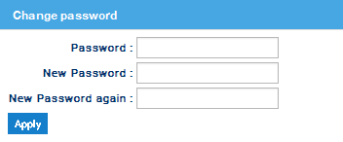

Figure 8. Change password

1. Type the current password in the **Password** text box.
2. Type a new password in the **New Password** text box. Make sure that the length of the password must be not more than 10 characters.
3. Re-type the new password in the **New Password again** text box and click **Apply**.
   * 1. Contacts

User can create contacts in their profile using **Contacts** option.

To create contacts, do the following:

1. Click **Personal** and then click **Contacts**. The **Contacts** dialog appears as shown in *Figure 9*.

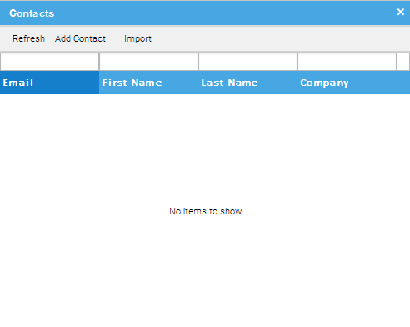

1. Figure 9. Contacts
2. Click **Add Contact**. The **Contact** dialog appears as shown in *Figure 10*.

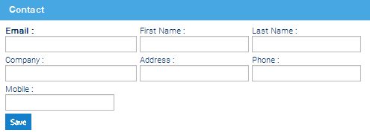

Figure 10. Contact details

1. Type **Email**, **First** **Name** and **Last** **Name** in the respective text boxes and click **Save**. The saved contact list appears as shown in *Figure 11*.
2. User can add additional information if needed. For example, **Company**, **Address**, **Phone**, **Mobile**.
3. **Import** option is disabled.

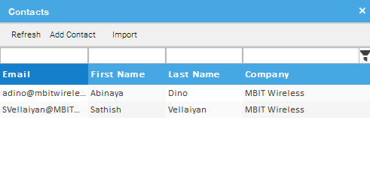

Figure 11. List of contacts

* + 1. Remove cookies

Cookies save the login credentials on your local machine for quick access in the future. If the user clicks **Remove cookies**, the user is logged out and the saved credential details are also deleted.

To remove cookies, click **Personal** and then click **Remove cookies** as shown in *Figure 12*.

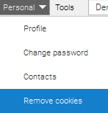

Figure 12. Remove cookies

* 1. Tools

The **Tools** menu contains **Dropbox** and **Text content**. A plain text editor is embedded in the application so the user can edit and create text files within MDMS. The text editing option is available in the **Tools** menu.

* + 1. Dropbox

The **Dropbox** option is disabled.

* + 1. Text content

**Text** **content** is a basic text editing option which is used to create, view and edit text files. A text file is a file type identified by the .txt file name extension. This helps to add and retrieve notes about a document.

To create a text file, do the following:

1. Click the **Tools** menu, point to **Text content** and then click Create document as shown in *Figure 13***.** The **Create text conten**t dialog appears as shown in *Figure 14***.**

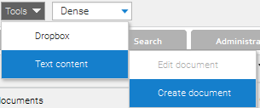

1. Figure 13. Tools menu

**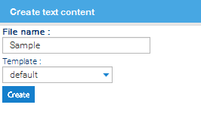**

1. Figure 14. Create text content
2. Type a file name in the File name text box as shown in*Figure 14***.**
3. **Select default from the Template drop-down list box as shown in** *Figure 15***.**

**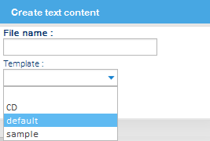**

1. Figure 15. Select template
2. **Click Create as shown in** *Figure 14***.** A text window with the file name appears on top of the window bar as shown in*Figure 16.*

****

Figure 16. File name extension

1. **Edit the text content and click Save to confirm or click Close to cancel as shown in***Figure 17***.**

**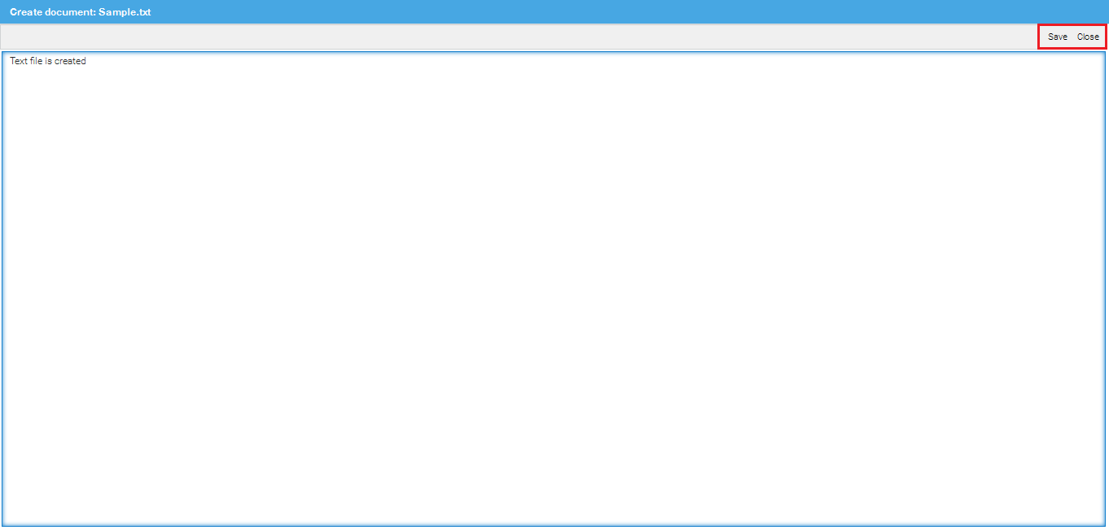**

Figure 17. Text window

* 1. Screen view

MDMS has the functionality to change the appearance of the screen. It is used to change the view of the MDMS screen in the system. This option gives control over screen layout, zooming the size of the view.

Select the type of screen view from the drop-down list box as shown in *Figure 18****Error! Reference source not found.***. The screen appearance changes accordingly.

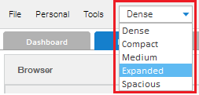

Figure 18. Types of screen view

The default screen view is **Dense**.

* 1. Dashboard

The dashboard contains **User, Tags** and **Messages**. Various alerts and statistics regarding the documents can be arranged within the dashboard.

* + 1. User

This section shows statistical information about user’s activities (for example, list of documents, last changed documents, currently checked out documents) in MDMS.

User can select the necessary dashlets from the **Dashlet selector** drop-down list box as shown in   
*Figure 19*.

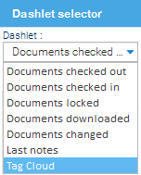

1. Figure 19. List of dashlets

All information is organized in dashlets. Each dashlet is a small window which can be arranged in the user screen based on the user’s preferences as shown in *Figure 20.*

This helps to keep track of all information from each dashlet in a single screen.

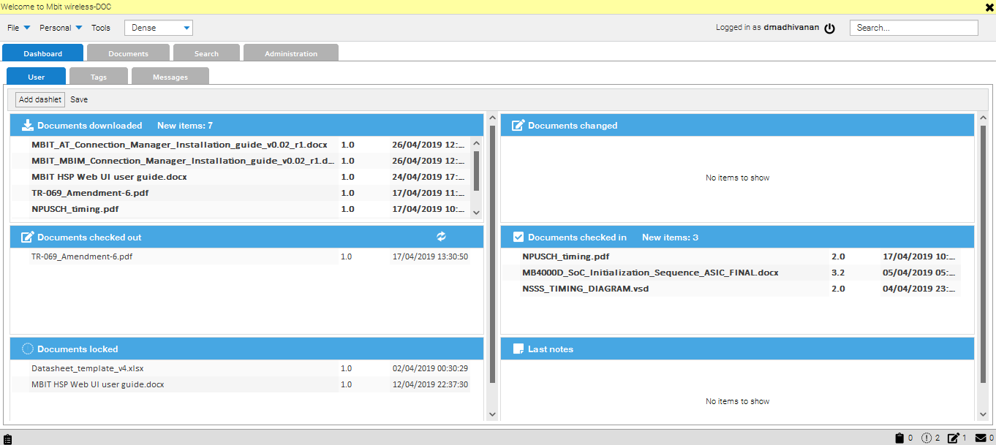

Figure 20. User logs

To add a dashlet, do the following:

1. Click **Add dashlet** on the upper-left corner of the **User** window. The **Dashlet selector** dialog appears as shown in *Figure 21*.

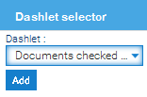

Figure 21. Dashlet selector

1. Select a dashlet from the **Dashlet** drop-down list box and then click **Add**.
2. Click Saveon upper-left corner of the **User** window to confirm the modifications.
3. Dashlets can be arranged in any direction within the **User** window. Keep the pointer on top of the dashlet, drag and keep in the desired position.
   * 1. Tags

This option is disabled.

* + 1. Messages

MDMS has an internal messaging system. It is used to send and receive messages from the added contacts.

To send message, do the following:

1. Click **Message**s tab and then click Send message as shown in *Figure 22***.** The Sendmessage dialog appears as shown in *Figure 23***.**

**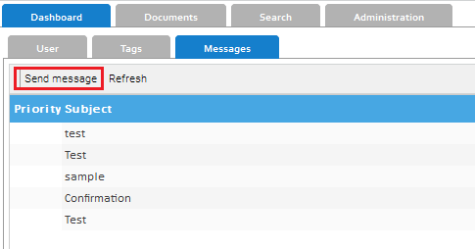**

1. Figure 22. Messages

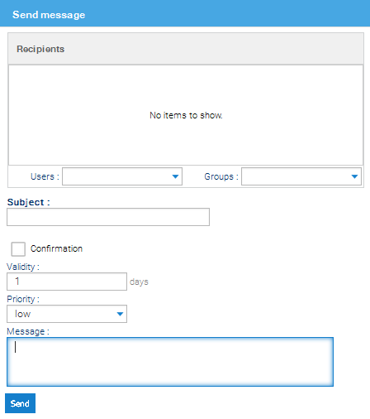

Figure 23. Send message

1. **Select a user from Users drop-down list box to send message individually or select a group from Groups drop-down list box to send in groups.**
2. **Multiple users can be added to the recipient list from the Users drop-down list box to send a message to multiple users.**
3. **If you want to remove a user from the recipient list, right-click the user name and then click Delete.**
4. Type a subject of the message in **Subject** text box and the content of the message in the **Message** text box.
5. Set a validity period in **Validity** text box. User can set a validity period to specify an expiry period after which the message is deleted. The message is no longer available to the recipient after expiry.
6. Select a priority from **Priority** drop-down list box. User can set a priority to a message as **low**, **medium** and **high** to let your recipient know its importance. The message indicates the priority level when received by the recipient.
7. Click **Send**. The sent message is displayed in the **Messages** window as shown in *Figure 24****Error! Reference source not found.***.
8. Click **Refresh** in **Messages** window to view the sent message as shown in *Figure 24****Error! Reference source not found.***.

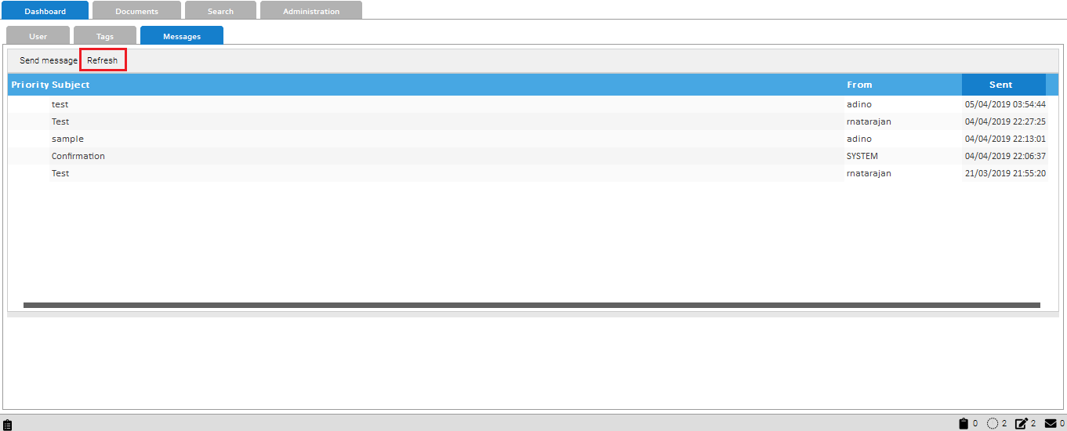

1. Figure 24. Messages
   1. Document and folder operations

**Documents** tab enable the user to navigate to the folders and documents in MDMS. It shows all the documents in the folder.

1. User can add folders and sub folders in a folder.

The **Documents** tab contains **Browser**, **Bookmarks** and **Trash** as shown in *Figure 25***Error! Reference source not found.**.

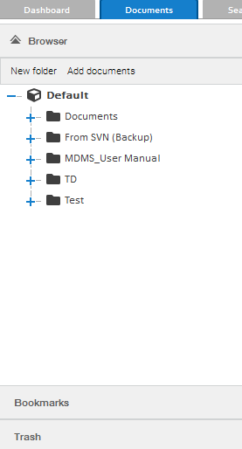

1. Figure 25. Options in documents
   * 1. Browser

List of existing folders is displayed in the **Browser** option. User can browse the needed document by clicking the respective folder.

1. Click **Browser** to access the folder structure.
2. Click\\INCHWSHR1\Technical_Documentation\MDMS\plus symbol.PNGto extend the folder,
3. Click a folder. The **Properties** and **Ext. Properties** of the selected folder and icons appear in the right side pane as shown in *Figure 26*.

User can edit all the fields in the **Properties** and **Ext. Properties** except the path and ID fields, which are auto-generated.

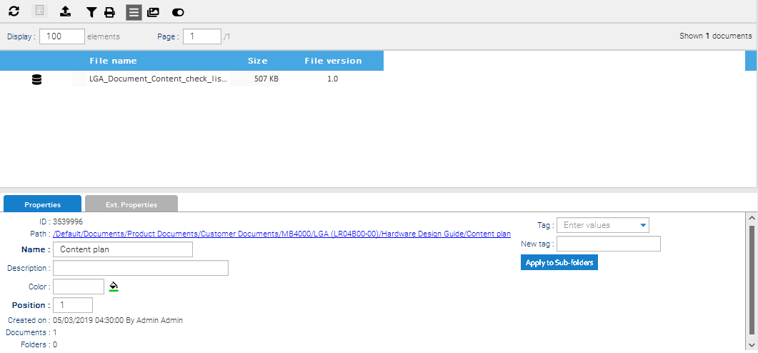

Figure 26. Folder properties

Click a document in a folder. The **Properties**, **Ext. Properties**, **Versions**, **Preview**, **Notes** and **Links** of the selected document appear as shown in *Figure 27****Error! Reference source not found.***.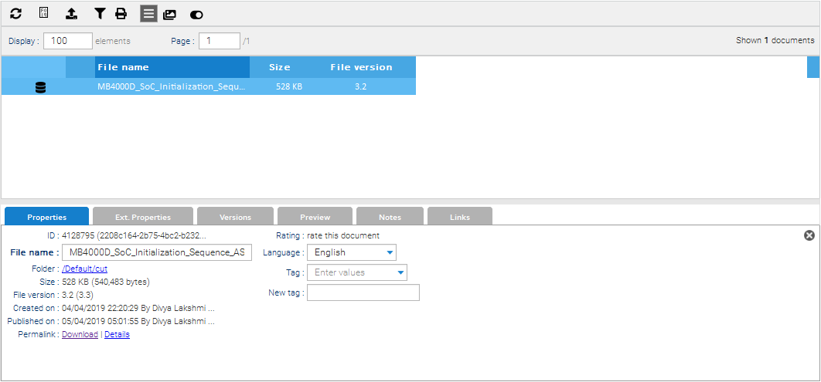

Figure 27. Document screen

* **Properties:** Only, **File name** of the document can be updated.
* **Ext. Properties:** All the fields can be modified except the **Custom ID** as shown in *Figure 28****Error! Reference source not found.***.

1. **Custom ID** is generated automatically, while adding a document to the folder.

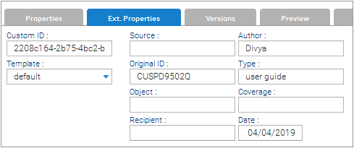

Figure 28. External properties

* **Versions:** User can view the version history of the selected document and also can download previous version of the document.
* **Preview:** Preview of the document. User can preview only PDF files.
* **Notes:** User can view and add notes about the document.
* **Links:** This option is disabled.

After the changes are made, a **Version comment** text box appears as shown in *Figure 29****Error! Reference source not found.***.

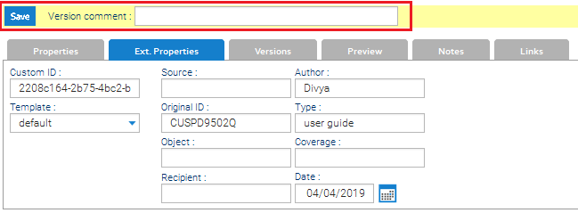

1. Figure 29. Version comment
2. Type a reason for the revision in the **Version comment** and click **Save** as shown in   
   *Figure 29*.

The icons available in the folder are listed in *Table 1****Error! Reference source not found.Error! Reference source not found.***.

Table 1. Icons in the folder

| Icons | Description |
| --- | --- |
| \\INCHWSHR1\Technical_Documentation\MDMS\Indexed icon.PNG | Document indexed and full-text searchable |
| \\INCHWSHR1\Technical_Documentation\MDMS\Bookmark icon.PNG | Document is bookmarked |
|  | Add documents |
|  | Filter |
|  | List |
|  | Gallery |
|  | Document preview   1. User can preview only PDF files. |
| \\INCHWSHR1\Technical_Documentation\MDMS\refresh icon.PNG | Refresh |
| \\INCHWSHR1\Technical_Documentation\MDMS\Download icon.PNG | Document download |
| \\INCHWSHR1\Technical_Documentation\MDMS\print icon.PNG | Print |
|  | Documents locked |
|  | Document checked out (documents locked or checked out (for editing)) |

* + 1. Bookmarks

Bookmarks are convenient way to access folders and documents that are used frequently. User can create bookmarks for folders and documents for quick access in the future. The document can be easily accessed by clicking its name in the bookmark list, instead of searching through **Browser** as shown in *Figure 32*.

To create bookmark, do the following:

1. To create a bookmark for folder, right-click the respective folder in **Browser** and then click **Add** **bookmark** as shown in *Figure 30*.

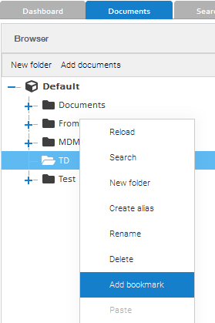

1. Figure 30. Add bookmark
2. To create a bookmark for document, right-click the document on the right side pane and then click **Add bookmark**. A bookmark icon appears as shown in *Figure 31*.

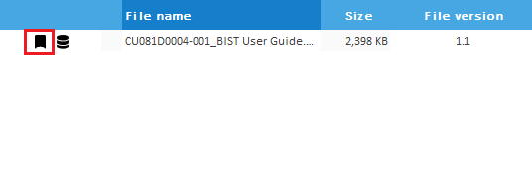

Figure 31. Bookmark icon

List of bookmarks created is displayed in the **Bookmarks** option as shown in *Figure 32*.

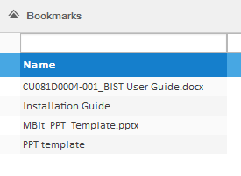

Figure 32. List of bookmarks

* + 1. Trash

When user deletes a file from MDMS, the deleted file is moved to **Trash** where it is stored temporarily. This helps to recover the deleted files and restore them to their original location.

The deleted files and folders are displayed in the **Trash** as shown in *Figure 33****Error! Reference source not found.***.

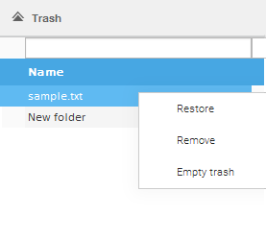

Figure 33. Delete file

* To restore the deleted files, right-click the file and then click **Restore**.
* To delete a file permanently, right-click the file and then click **Remove**.
* To delete all files permanently, right-click the file and then click **Empty trash**.
  1. Search documents

MDMS provides several ways to find the files and folders. Search option allows quick access to the information. When search is performed, only the indexed files appear in search results. It is recommended to index a file when it is added in a folder. Refer to section *6.1*.

As you type, the items that match your text appear on the screen. The search is based on text in the file name and other file properties.

On upper-right corner of the home page, a quick **Search** text box is available. User must type a search expression and then press **Enter** as shown in *Figure 34*.***Error! Reference source not found.***

\\INCHWSHR1\Technical_Documentation\MDMS\Screenshots\New\Search - right corner.png

1. Figure 34. Quick search text box

Search can be done in three different ways: **Full-text**, **Tags** and **Folders**.

* + 1. Full-text search

The full-text search option is the fastest way to search for documents in MDMS. The full-text search allows to search in contents of the documents.

To perform full-text search, do the following:

1. Click **Full-text** in **Search** tab as shown in *Figure 35*.
2. Type the file name in **Expression** text box and type the remaining filters only if needed else press **Enter** as shown in *Figure 35*.
3. Select the language from **Language** drop-down list box and select **Search in current hits** checkbox.
4. Type the folder name in **Folder** text box and select **Search in subfolders** checkbox to search also in the respective subfolders of the specified folder as shown in *Figure 35*.

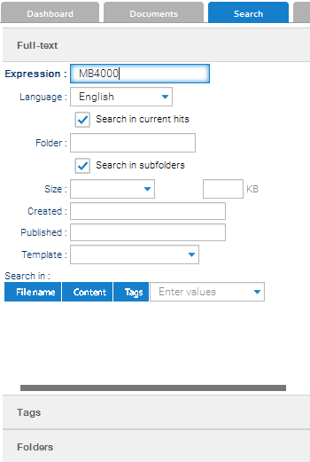

Figure 35. Search by Full-text

1. Select the size from **Size** drop-down list box and type the file size in **KB** text box.
2. Click **Created** text box. The **Select Date Range** dialog appears as shown in *Figure 36*.
3. Type the **From** and **To** dates in the respective text boxes to set the time period and click **Ok** to confirm or click **Cancel** to close the dialog or click **Clear** to delete the mentioned time period.

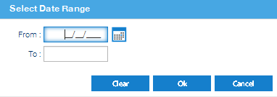

1. Figure 36. Date range
2. Click **Published** text box. The **Select Date Range** dialog appears as shown in *Figure 36.*
3. Type the **From** and **To** dates in the respective text boxes to set the time period and click **Ok** to confirm or click **Cancel** to close the dialog or click **Clear** to delete the mentioned time period.
4. Select **default** from the **Template** drop-down list box as shown in *Figure 37*.

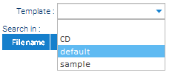

1. Figure 37. Select template
2. Select value(s) from **Enter values** drop-down list box as shown in *Figure 38****Error! Reference source not found.***.

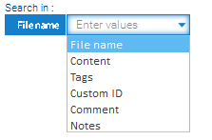

Figure 38. Search in fields

1. It is possible to restrict the search of the text expression from the selected values in **Search in** section as shown in *Figure 35****Error! Reference source not found.***.
2. Keep the cursor in the the **Expression** text box and press **Enter**.
3. Search is done only when the cursor is kept in the **Expression** text box as shown in   
   *Figure 35*.
   * 1. Search by tags

This option is disabled as mentioned in section *4.5.2*.

* + 1. Search by folder

User can search folders using the **Folders** option. To perform this search, add as many conditions as needed to find the desired folder.

It is possible to restrict the search to a parent folder when the **Search** **in subfolders** checkbox is cleared.

To search a folder, do the following:

1. Type the folder name in **Parent** text box and select **Search in subfolders**, **Case** **Sensitive**, if needed as shown in *Figure 39*.
2. **Retrieve aliases** option is disabled.

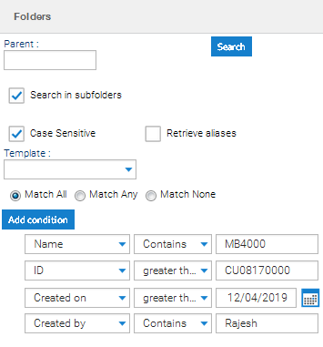

Figure 39. Search by folder

1. Select the **default** template from the **Template** drop-down list box.
2. Click **Add condition** several times to add multiple conditions in search as shown in   
   *Figure 39*.
3. Choose a type of **condition** from the drop-down list box as shown in *Figure 40*.

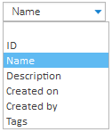

1. Figure 40. Condition
2. Select the value from the drop-down list box to add value to the pre-selected condition as shown in *Figure 41*.

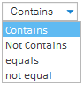

1. Figure 41. Values
2. Type a key word in the text box to fulfil the conditional filtering for precise search operation. For example, if you have selected **Name** and **Contains** from the drop-down list boxes, type a key word (MB4000) in the text box as shown in *Figure 42*.

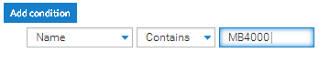

1. Figure 42. Key word
2. Repeat the steps *4* to *6* for all other type of conditions.
3. Click **Search** after all the search details are added.
   1. Status bar icons

For each record or action, a set of icons is defined to indicate the status of the action.

The most important icons in the status bar are listed in *Table 2*.

Table 2. Status bar icons

| Icons | Description |
| --- | --- |
| \\INCHWSHR1\Technical_Documentation\MDMS\Last events icon.PNG | Last events (number of workflow tasks) |
|  | Clipboard (documents, text in the clipboard while copying) |
|  | Documents locked |
|  | Document checked out (documents locked or checked out (for editing)) |
|  | Messages (Newly arrived messages) |

To view last events, do the following:

1. Click \\INCHWSHR1\Technical_Documentation\MDMS\Last events icon.PNG on the lower-left corner of the MDMS screen. The **Last Events** dialog appears as shown in *Figure 43*.
2. Keep the pointer on the upper-right corner of the dialog and click \\INCHWSHR1\Technical_Documentation\MDMS\Delete icon.PNG to delete the last events history or click\\INCHWSHR1\Technical_Documentation\MDMS\Close symbol.PNG to close the dialog.

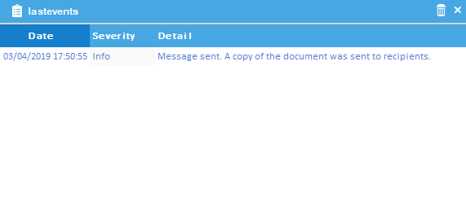

Figure 43. Last events

1. Folder management

Folder is a container of your files. Every file is stored in a folder or in a subfolder. This section focuses on how to create a folder and perform folder operations.

Click a folder in **Browser**. At the right side pane, a grid shows all the documents in the folder as shown in *Figure 44*.

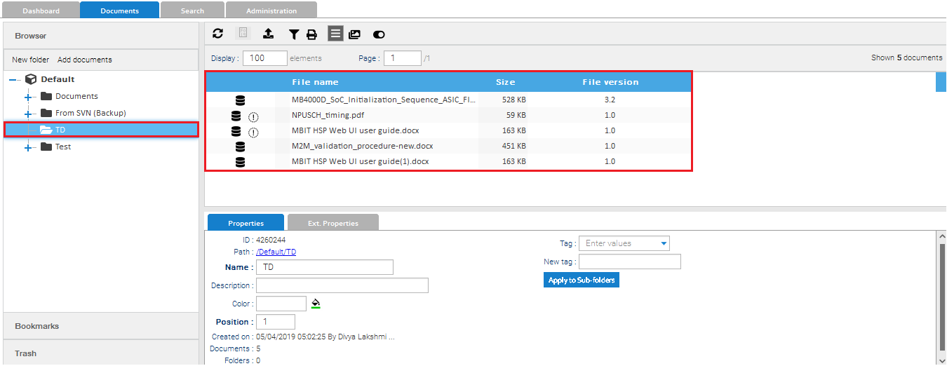

Figure 44. Documents in the folder

To create a folder, do the following:

1. Click **Default** and then click **New** **folder** as shown in *Figure 45***Error! Reference source not found.**.

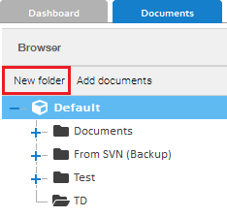

Figure 45. Add new folder

1. To create a sub folder, select a parent folder and then click **New** **folder** or right-click the parent folder and then click **New folder** as shown in *Figure 46*.

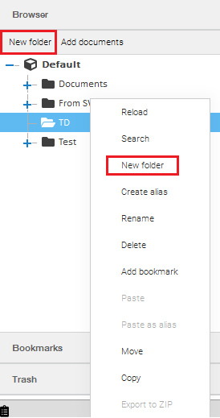

1. Figure 46. Folder operations

The following operations are performed in a folder as shown in *Figure 46***Error! Reference source not found.**.

**Reload:** Refresh the folder

**Search:** Search the folder. If user clicks **Search**, it automatically directs to the **Search** tab. User can type the expression or file name in the appropriate search text box as mentioned in section *4.7.3.*

**Rename:** To rename a folder

**Delete:** To delete a folder

**Add bookmark:** Add bookmark to a folder

**Move:** Move folder and contents from one location to another location, refer to section *5.1*.

**Copy:** To copy a folder to another location, refer to section *5.2.*

* 1. Move a folder

To move a folder into another location, do the following:

1. Right-click a folder and then click **Move**. The **Move** dialog appears as shown in *Figure 47*.
2. Select a desired folder to transfer and then click **Move**. A dialog appears for confirmation as shown in *Figure 48*.

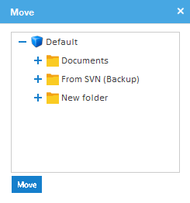

1. Figure 47. Move folder

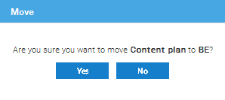

Figure 48. Move request confirmation

1. Click **Yes** to confirm or click **No** to cancel the request as shown in *Figure 48*.
   1. Copy a folder

To copy a folder to another location, do the following:

1. Right-click a folder and then click **Copy**. The **Copy** dialog appears as shown in *Figure 49*.
2. Select a desired folder to paste the copied folder.

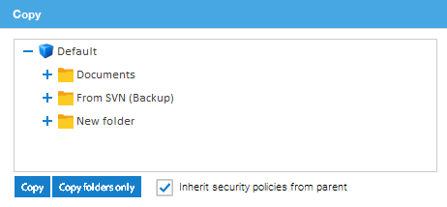

Figure 49. Copy folder

1. Click **Copy** to paste the entire folder and contents or click **Copy folders only** to paste the folder alone. A dialog appears for confirmation as shown in *Figure 50.*
2. The **Inherit security policies from parent** checkbox in the dialog is selected by default. User cannot change the preference in MDMS.

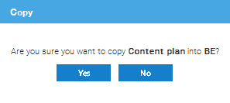

Figure 50. Copy request confirmation

1. Click **Yes** to confirm or click **No** to cancel the request as shown in *Figure 50*.
2. Document management

This section focuses on how to add documents in a folder and perform document operations.

* 1. Add documents

After folder is created, add documents by clicking  in the right side pane. The **Add documents** dialog appears as shown in *Figure 51*.

1. Select the **Immediate indexing** checkbox.
2. Indexing helps to associate information with a file so it can be used for search and retrieval purposes later.
3. **Import documents from ZIP** checkbox is disabled.

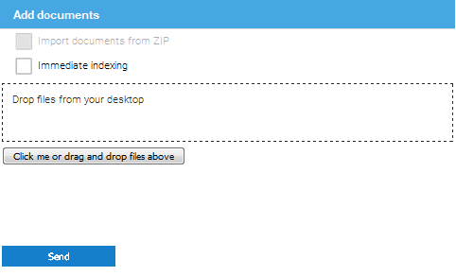

Figure 51. Add documents

1. Click the **Click me or drag and drop files above**. The **File Upload** dialog appears as shown in *Figure 52*.

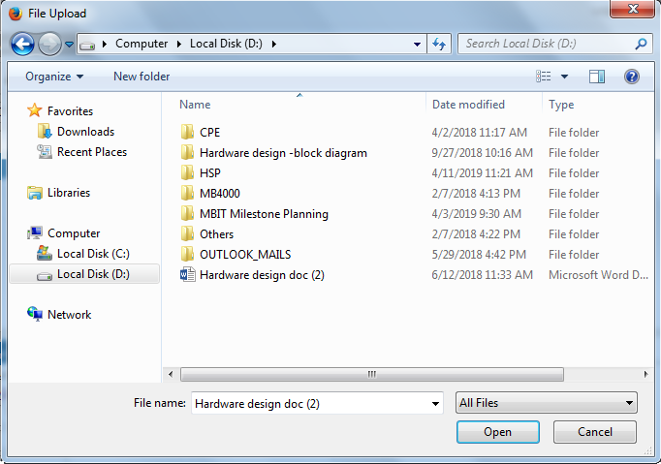

Figure 52. File upload

1. Select the files from the desired location and click **Open** or drag and drop multiple files in **Drop files from your desktop** text box from the respective location.
2. Click **Send** as shown in *Figure 51*. The **Properties** tab appears as shown in *Figure 53*.

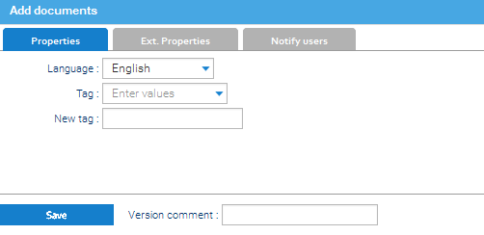

Figure 53. Set properties

1. Click **Ext. Properties** tab shown in *Figure 54*.

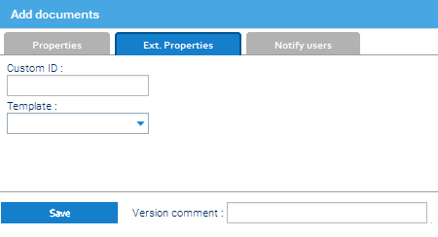

Figure 54. Set external properties

1. Select **default** from **Template** drop-down list box.
2. Template allows to define document types and attribute sets when user uploads or edits a document. **Source**, **Author**, **Original ID**, **Type**, **Object**, **Coverage**, **Recipient**, **Date** are the available attributes in template.

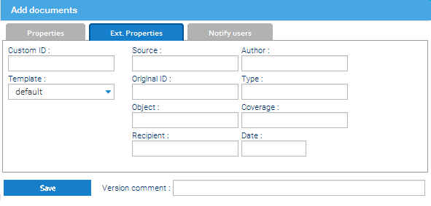

Figure 55. Template attributes

1. If needed, click **Notify users** tab and select a user from **Users** drop-down list box as shown in   
   *Figure 56*.

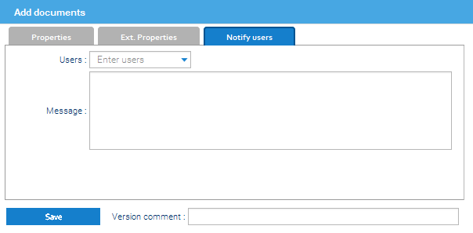

Figure 56. Notify users

1. Type a message in **Message** text box.
2. Type a comment in **Version comment** text box.
3. Click **Save**.
   1. Document operations

To view document operations, right-click the document in the right side pane. The operations are displayed in the menu as shown in *Figure 57*.**Error! Reference source not found.**

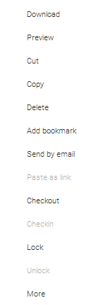

Figure 57. Document operations

The following document operations are performed in a folder as shown in *Figure 57*.

**Download:** To download a copy of the document to the local machine.

**Preview:** To preview the document (Only PDF files can be previewed) in MDMS.

**Cut:** To move a document from one location to another location.

**Copy:** To copy a document and paste to another location.

**Delete:** To delete a document.

**Add bookmark:** To add bookmark to a document, refer to section *4.6.2*.

**Send by email:** To share the document to other users,refer to section *6.2.1*.

**Checkout:** To check out a document from a folder for new revision, refer to section *6.2.2*.

**Checkin:** To add a new version of a checked out document in a folder, refer to section *6.2.3*.

**Lock:** To lock a document, refer to section *6.2.4*.

**Unlock:** To unlock a locked document.

**More:** This option is disabled.

* + 1. Send by email

To send document by email, do the following:

1. Type the mail ID in **To** text box as shown in *Figure 58*.
2. Type the message in message text box.

**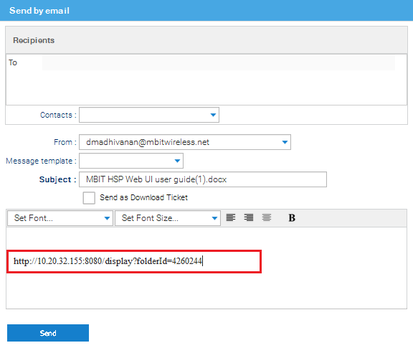**

Figure 58. Send document by email

1. Click the document folder and copy the **Path** link available in the **Properties** tab at the right side pane into message text box as shown in *Figure 59* and *Figure 58*.

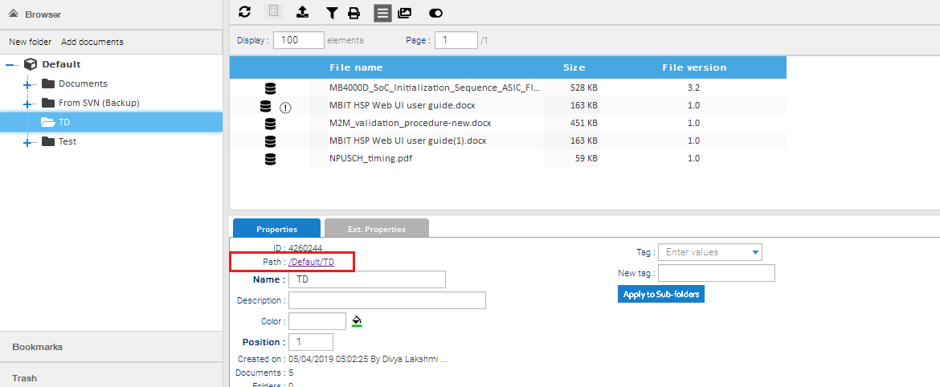

Figure 59. Folder link

1. Click **Send**. A notification appears on the screen as shown in *Figure 60.*

User can access the document through the link sent in the message. The sent mail ID is saved for future use to access quickly.

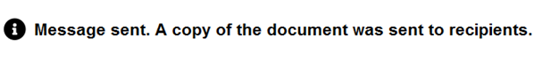

Figure 60. Message notification

* + 1. Checkout

To check out a document, do the following:

1. Right-click a document and then click **Checkout**. A dialog appears to save or open the file as shown in *Figure 61*.

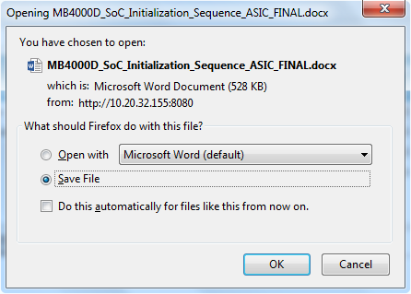

Figure 61. Save document

1. Select **Save File** checkbox and click **OK**.
2. Edit the document and make changes as required.
   * 1. Checkin
3. **Checkin** option is enabled only when a document is checked out. Only the owner can perform a **Checkin**.

To checkin a revised document to a folder, do the following:

1. Right-click a document and then click **Checkin**. The **Checkin** dialog appears as shown in *Figure 62*.

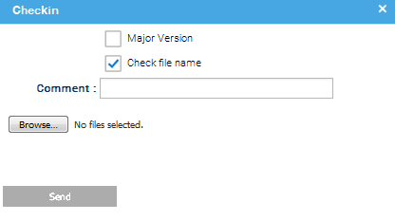

Figure 62. Document checkin

1. Click **Browse** to select documents from the desired location.
2. Select the **Check file name** and **Major Version** check boxes if needed.

When user selects the **Check file name** check box and uploads an incorrect file in MDMS, a warning message appears as shown in *Figure 63*.

If user want to replace an existing file with different file name, then clear the **Checkin file name** checkbox.

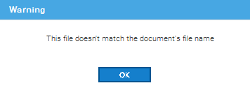

Figure 63. Warning message

1. Type the comments in **Comment** text box and click **Send**.
2. Click **Ext. Properties** and select **default** from **Template** drop-down list box as shown in   
   *Figure 64*.
3. Type the required details in the respective text boxes if needed and then click **Checkin**.

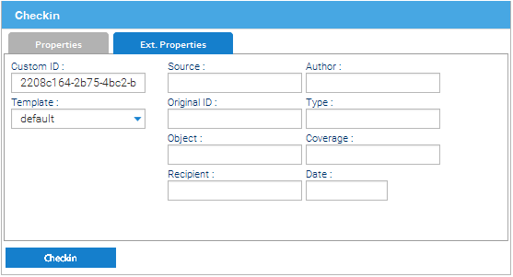

Figure 64. Add external properties

The version history is captured in **Versions** tab at the right side pane as shown in *Figure 65*.

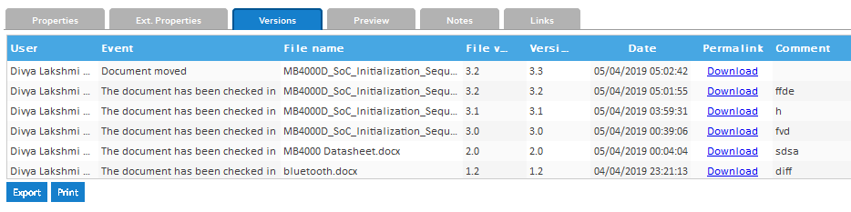

Figure 65. Version history

1. User can save the Version history in XPS format by clicking the **Print** option as shown in   
   *Figure 65*.
2. **Export** option is disabled.
   * 1. Lock and unlock

To lock a document, do the following:

1. Right-click a document and then click **Lock**. The **Info** dialog appears as shown in *Figure 66****Error! Reference source not found.***.
2. Type a reason in **Give a reason for this lock** text box.

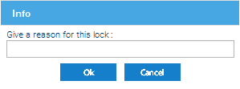

Figure 66. Reason for document lock

1. Click **Ok** to confirm or click **Cancel** to cancel the request.  Icon appears near the document on the right side pane as shown in *Figure 67****Error! Reference source not found.***.

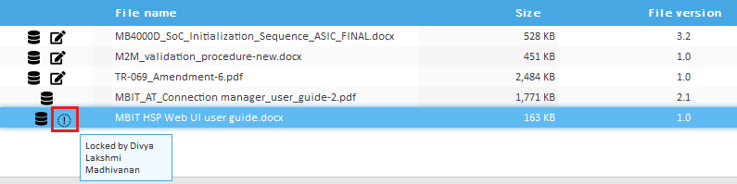

Figure 67. Locked document

Keep the pointer on  to view that who locked the document as shown in *Figure 67****Error! Reference source not found.***.

1. If the document is locked, no other user can work on the particular document unless the document is unlocked by the owner.
2. Right-click a locked document and then click **Unlock** to release the lock.
3. **Unlock** option is enabled only when a document is locked. Only the owner can unlock a document.